How to Complete an Agreement with Instructors
Related to “Reasonable Modification” Accommodations
First, Log into the SDAC Portal using your Netbadge login: Under My Accommodations on the left, click “Agreements with Instructors”.

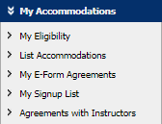
Step 1
- Select Class from drop-down menu and click “Create Agreement With Instructor”.

- Please take your time and read the information and guidelines provided. This will help you and your professor work together for the best accommodation for the class.

- Check that your professor is listed. If they are not please email us at SDAC@virginia.edu, with the correct professor and their email address and we will add them. We can add TA/GA’s if that is what your professor prefers.

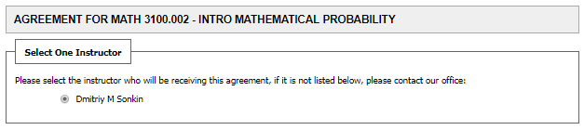
Professor Name
- Please consult with your professor to fill out the form(s) below. There is an copy of the text of the questions at the end of this document. You can send them the questions or meet with them in person. SDAC suggests to always offer to meet with them in person.

- Sign the Honor Code agreement. Then “Submit Agreement with Instructor”.
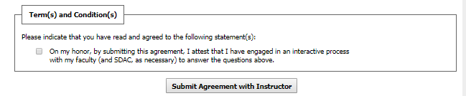
- Your professor will get a copy of this agreement for their records. You will be able to log in to the portal to reference your agreements. Please email your SDAC advisor if you have any concerns or questions about your agreements.
Continue to next page

Formatted copies of the Agreement Worksheets
Below you will find the description of the accommodation that is included in the agreement worksheet. We have reformatted it, so you can easily include it in an email to your instructor when reaching out to find a time to discuss the accommodation(s) in depth. Particularly as this is a new system, it is important to provide your professor with this information.

Reasonable Modification of Assignment Deadlines
SDAC Description: The purpose of this accommodation is to suggest that extended time on course assignments may be a reasonable accommodation when a student’s disability impacts their ability to complete an assignment by the published deadline. If the student has a disability with random or cyclical acute episodes, the accommodation allows for flexibility in assignment deadlines and make up work. This does not mean open-ended deadlines.
Students with this accommodation have a responsibility to anticipate their need for and request an extension prior to the published deadline. In addition, students should not plan on the granting of an extension as matter of course, and should use this accommodation with care. Students should initiate a conversation early in the semester, or upon onset of disability, to determine how to apply the accommodation in this course. Questions to guide your conversation may include:
- What are the course practices and policies regarding deadlines?
- What method is used to calculate the final grade?
- Does the fundamental nature of the course rely on meeting deadlines as an essential component for learning?
- To what degree does the student's failure to submit timely work impact others in the class?
- Are assignments used as course content when they are due (e.g. problem sets reviewed as the first lecture on that content)?
Faculty are not required to lower the requirements of their course, nor to apply accommodations in a retroactive manner. The number of days given for each assignment extension is determined on a case-by-case basis, and depends upon the interactive process between the student, the faculty, and SDAC. Where granted, extensions are typically short, that is, a matter of a day or two. For extensions longer than 5-7 days, students should meet with their SDAC Advisor to consider alternative strategies. If an extension is granted, specific information should be communicated between the faculty and student regarding the revised due date and time.
Questions: Reasonable Modification of Assignment
- What the assignment deadline policy is as stated in the syllabus?
- How many additional days would be reasonable for an extension and still allow for the student to fulfill the learning outcomes of the course?
- Are there key assignments in this course for which an extension is not a reasonable accommodation?
  - Yes - Please detail assignments and rationale for how an extension would constitute a fundamental alteration of the course. (Specify Below)
- SDAC requires students to contact their faculty/TA prior to the published deadline if they will need an extension for a disability-related reason. What is the faculty’s preferred method of contact?
  - Email
  - Phone
  - Text
  - Other

Reasonable Modification of Course Attendance Policy
SDAC Description: This accommodation is intended to create some flexibility of the attendance policy in the course to allow for a reasonable number of disability-related absences. This does not mean unlimited absences.
For this accommodation, it must first be determined whether or not a modification of the attendance policy would constitute a fundamental alteration of the course. This may be determined by a collaboration between SDAC and the faculty member. The following questions may help frame the discussion:
- What do the course description and syllabus say?
- What elements of the class experience are used to calculate the final grade?
- What are the classroom practices and policies regarding attendance?
- Do student discussions and contributions constitute a significant component of the learning process?
- Does the fundamental nature of the course rely on student participation as an essential method for learning?
- To what degree does a student’s failure to attend constitute a significant loss to the educational experience of other students in the class?
If it is determined that flexibility with absences would be appropriate in the course, then the student, faculty, and SDAC (if necessary) must dialogue to determine an appropriate number of absences beyond what is stated in the syllabus. This number is going to be variable for each course, and may take into account the format in which the course is taught, number of course meetings, and the level of interaction required by the student.
Students are also advised that they still bear the responsibility to communicate with instructors about their absences as they occur, keep up with the reading, obtain class notes from a fellow student, and make up any assignments they may have missed. Instructors are not obligated to create extra work for either the student or themselves as a substitute for “participation” in class or missed assignments. However, instructors are encouraged to consider whether there are opportunities for the student to mitigate or “make up” their absence.
This accommodation is subject to a reasonableness standard, and is not appropriate in every circumstance. In cases where attendance is an essential part of the class, a withdrawal or an incomplete may be considered a reasonable alternative if absences become excessive.
Questions: Reasonable Modification of Course Attendance Policy
- What is the attendance and participation policy as stated in the syllabus?
- What number of additional absences would be reasonable and still allow the student to fulfill the learning outcomes of the course?
- Considering the questions above, what is the total number of absences allowed for this student?
- If a student misses a class for a disability-related reason, what is the plan for making up missed work?
- If a student misses an exam or quiz for a disability-related reason, what is the plan for making up the assessment?
- SDAC requires students to contact their faculty/TA prior to the class meeting if they will be absent for a disability-related reason. What is the faculty’s preferred method of contact?
  - Email
  - Phone
  - Text
  - Other

