Requesting Accommodations from SDAC at UVA
At the beginning of each semester, you need to request “Faculty Notification Letters” for each class in which you want to use your approved accommodations. We suggest doing this in the first two weeks of the semester. Here’s how:

Log into the SDAC portal: SDAC Portal
  - Use your net badge account to log in.

- Under Step 1: Select Class(es)- select your class(es) that you would like accommodations
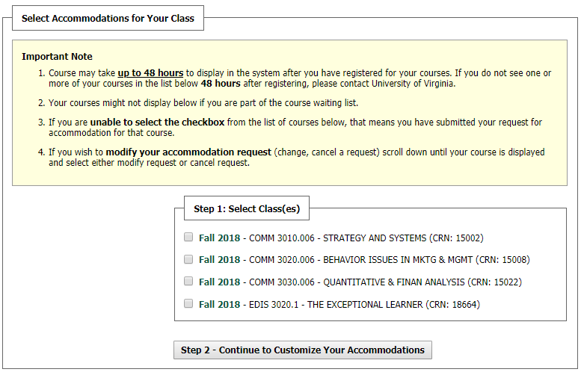
Step 1
Step 2
  - If you do not see your classes listed and they do not populate after 48 hours please contact SDAC.

- Click continue to customize your accommodations

Continue to next page
- Select the checkbox of the accommodations you want your professors to know about.
  - Note: you may choose different accommodations for different professors/ classes
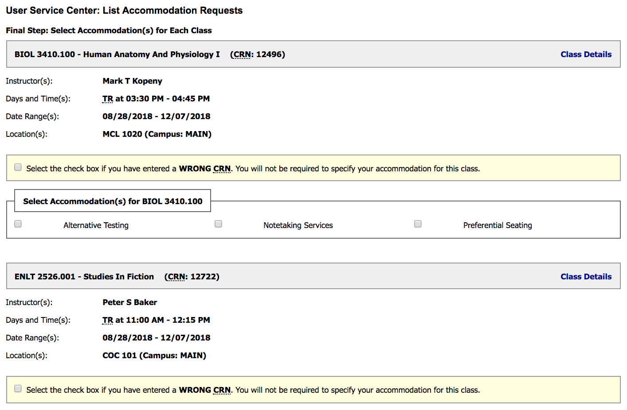
Step 3

Step 4
- Click “Submit Your Accommodation Requests”.

- This will alert SDAC that you have requested your letters; we will then email them to your professors, typically within one business day.
  - You will be copied on the email.

- Please also follow up with your professors in person!

Here is a link to a more detailed video about this topic: Requesting Accommodations Video

