Submitting an Alternative Testing Contract
First, Log into the SDAC portal using your net badge login: SDAC Portal
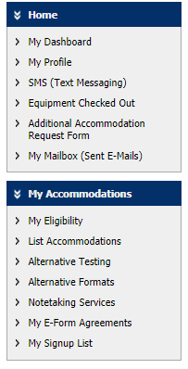
- Under My Accommodations on the left, click “Alternate Testing”.
Step A
- If you do not see your class listed: click “submit alternative testing contract” in the top right.
Step 1

Step B
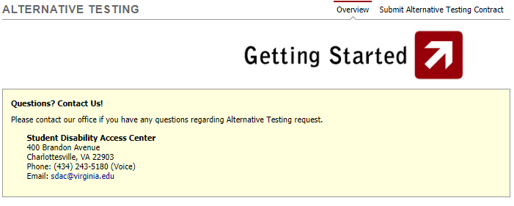

- Under step 1- select your class. Select the class you are filling out an Alternative Testing Contract.
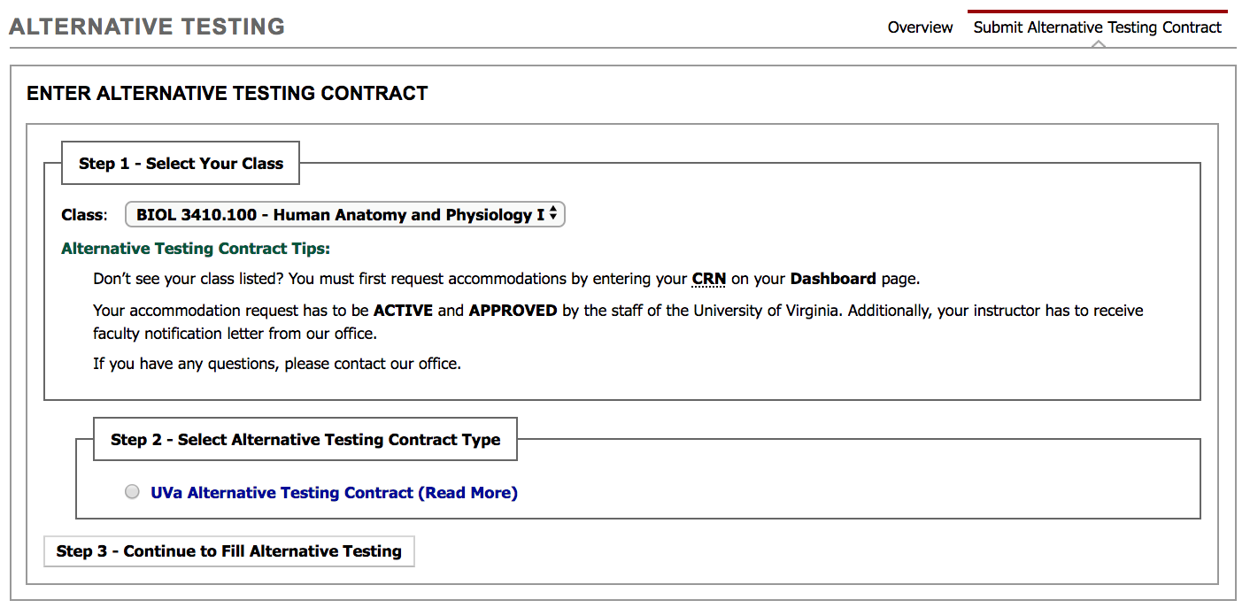
Step 1
Step 2
Step 3
- Under step 2- Select Alternative Testing Contact type click “UVa Alterative Testing Contract”.

- Click “Step 3- Continue to Fill Alternative Testing”

- Please meet or consult with your professor before filling out the Alternative Testing form to ensure sending the right information.
  - Your professor will be sent a copy of this form, so it is best to get this information entered correctly from the beginning.

- Scroll down and answer the questions to the best of your ability. If you have any questions please consult your professor about their preferences.
  - For exam length please write the time in minutes for the regular scheduled exam. Please do not to include the extra time.
    - 1 hour 15 minute = 75 minutes
    - 1 hour 30 minute = 90 minutes
    - 2 hours = 120 minutes
    - 3 hours-= 180 minutes
  - For additional information put the number of the professor that we can best reach them during this exam. A cell or an office number, whichever is the professor’s preference.

Continue to next page
- Under Terms and conditions.
  - Check the honor statement saying that the information you have submitted is true to the best of your knowledge.
  - Check the change of proctoring statement that if anything changes prior to the exam you will let SDAC know.

- Click Submit Alternative testing button under the terms and conditions box.

Here is a link to a more in-depth video tutorial for this topic” Alternative Testing Contract Video

