Submitting Proctoring Instructions

First, Log into the SDAC portal using your Netbadge login: SDAC Portal
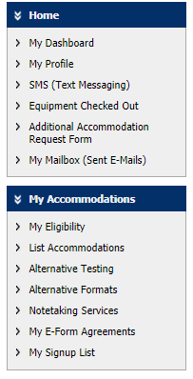
- Under My Accommodations on the left, click “Alternate Testing”.
Step A
- If you do not see your class listed: click “Submit Proctoring Instructions” in the top right.
Step 1

Step B
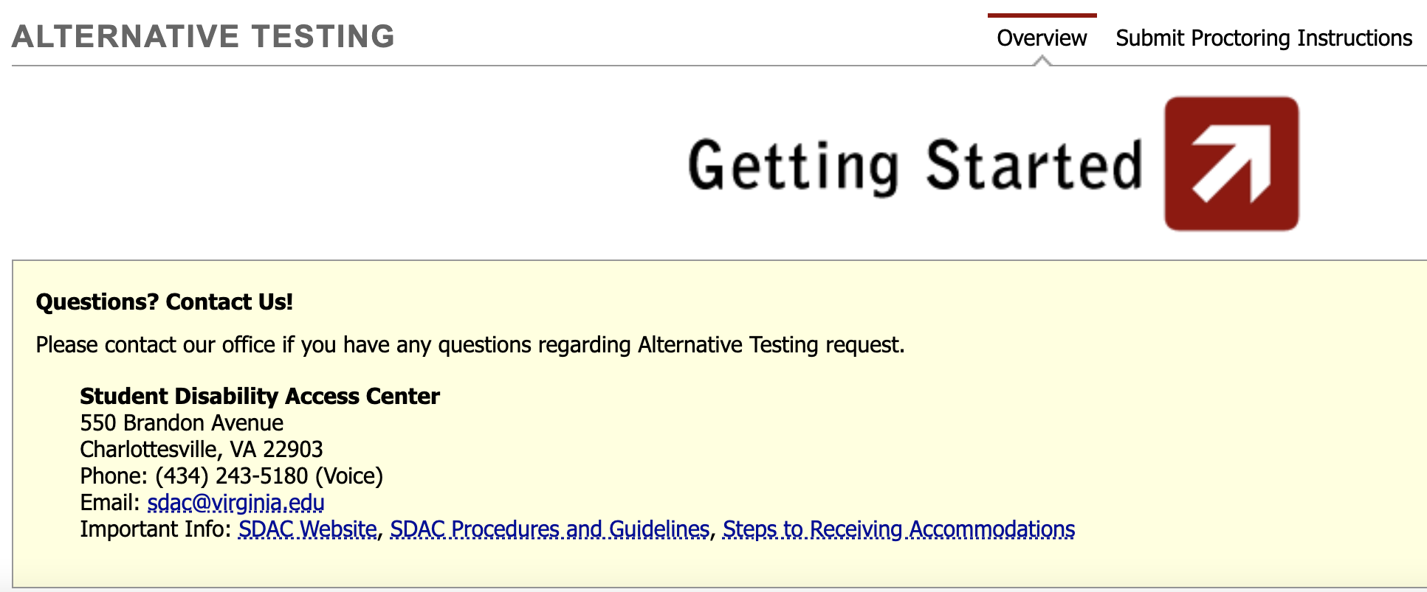
- Under step 1- select your class. Select the class you are filling out Proctoring Instructions.
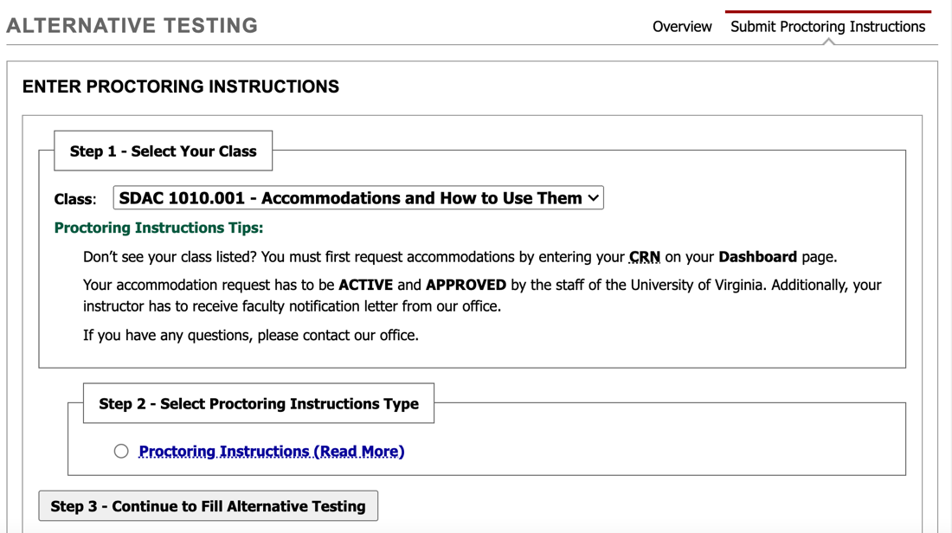
Step 3
Step 2
Step 1
- Under step 2- Select Proctoring Instructions type click “Proctoring Instructions”.

- Click “Step 3- Continue to Fill Alternative Testing.”

- Please meet or consult with your professor before filling out Proctoring Instructions to ensure sending the right information. Your professor will be sent a copy of this form, so it is best to get this information entered correctly from the beginning.

- Scroll down and answer the exam detail questions to the best of your ability. If you have any questions, please consult your professor about their preferences.
  - For exam length please write the time in minutes for the regular scheduled exam. Please do not to include the extra time; we will calculate that for you.
    - 1 hour 15 minute = 75 minutes
    - 1 hour 30 minute = 90 minutes
    - 2 hours = 120 minutes
    - 3 hours = 180 minutes
  - For additional information put the number of the Faculty that we can best reach them during this exam. A cell or an office number, whichever is Faculty’s preference.

- Read and click through the Terms and Conditions.
  - Check the honor statement saying that the information you have submitted is true to the best of your knowledge.
  - Check the change of proctoring statement that if anything changes prior to the exam you will let SDAC know.

- Click Submit Alternative Testing button under the terms and conditions box.

Here is a link to a more in-depth video tutorial for this topic” Submitting Proctoring Instructions

